**Library Management System**

| **Search Type** | **Time Complexity** | **Best For** |
| --- | --- | --- |
| **Linear Search** | O(n) | Unsorted or small datasets |
| **Binary Search** | O(log n) | Sorted, large datasets |

**CODE:**

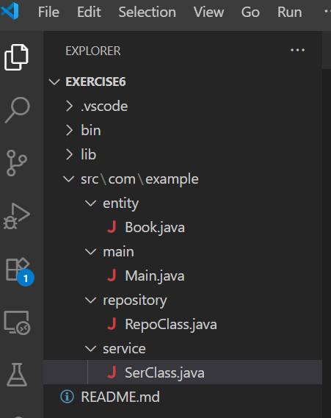

Book.java:

package com.example.entity;

public class Book {

private int id;

public String title;

private String author;

public Book(int id, String title, String author) {

this.id = id;

this.title = title;

this.author = author;

}

public int getId() {

return id;

}

public void setId(int id) {

this.id = id;

}

public String getTitle() {

return title;

}

public void setTitle(String title) {

this.title = title;

}

public String getAuthor() {

return author;

}

public void setAuthor(String author) {

this.author = author;

}

@Override

public String toString() {

return "Book [id=" + id + ", title=" + title + ", author=" + author + "]";

}

}

Main.java:

package com.example.main;

import java.util.Arrays;

import java.util.Comparator;

import java.util.Scanner;

import com.example.entity.Book;

import com.example.service.SerClass;

public class Main {

private static Scanner sc = new Scanner(System.in);

private static SerClass ser = new SerClass();

public static void main(String args[]) {

Book[] book1 = {

new Book(1, "Pride and Prejudice", "Jane Austen"),

new Book(2, "Adventure of Sherlock Homes", "Authur Conan Doyle"),

new Book(3, "Tale of 2 cities", "Charles Dickens"),

new Book(4, "War and Peace", "Leo Tolstoy"),

new Book(5, "Odyssey", "Homer")

};

System.out.println("Linear Search : ");

System.out.println();

System.out.print("Enter the Book title to search : ");

String name = sc.nextLine();

System.out.println();

Book result1 = ser.linear(book1, name);

System.out.println();

System.out.println(result1 != null ? "Title Found = " + result1 : "Title not found");

Arrays.sort(book1, Comparator.comparing(p -> p.title.toLowerCase()));

System.out.println();

System.out.println("Binary Search : ");

System.out.println();

System.out.print("Enter the Book title to search : ");

String name2 = sc.nextLine();

Book result2 = ser.binary(book1, name2);

System.out.println();

System.out.println(result2 != null ? "Title Found = " + result2 : "Title not Found");

}

}

RepoClass.java:

package com.example.repository;

import com.example.entity.Book;

public class RepoClass {

public Book linear(Book book[], String name) {

for (Book b : book) {

if (b.title.equalsIgnoreCase(name)) {

return b;

}

}

return null;

}

public Book binary(Book book[], String name) {

int left = 0;

int right = book.length - 1;

while (left <= right) {

int mid = (left + right) / 2;

int cmp = book[mid].title.compareTo(name);

if (cmp == 0) {

return book[mid];

} else if (cmp < 0) {

left = mid + 1;

} else {

right = mid - 1;

}

}

return null;

}

}

SerClass.java:

package com.example.service;

import com.example.entity.Book;

import com.example.repository.RepoClass;

public class SerClass {

private static RepoClass repo = new RepoClass();

public Book linear(Book book[], String name) {

return repo.linear(book, name);

}

public Book binary(Book book[], String name) {

return repo.binary(book, name);

}

}

## **Output :**

